**GIS410: Intro to Remote Sensing**

**Lab 5: Classification**

**Due: Thursday, April 1st, at 11:59 PM**

**100 points**

**Submit to Blackboard a single PDF document that includes:**

1. Completed statistics table (16 points)
2. The answers to the Lab 4 questions below (54 points)
3. Submitted images (30 points)

|  |  |  |
| --- | --- | --- |
| Land Cover Type | Supervised | Unsupervised |
| Water | 2 | 3 |
| Developed | 29 | 10 |
| Forest | 45 | 41 |
| Cropland / Pasture | 24 | 46 |

**QUESTIONS**

Q1: When reviewing the separability statistics, which two classes will be easiest to separate in terms of their spectral statistics? Which two classes will be hardest to separate in terms of their spectral statistics? Do these results match your experience when trying to identify classes in the Landsat scene? (6 points)

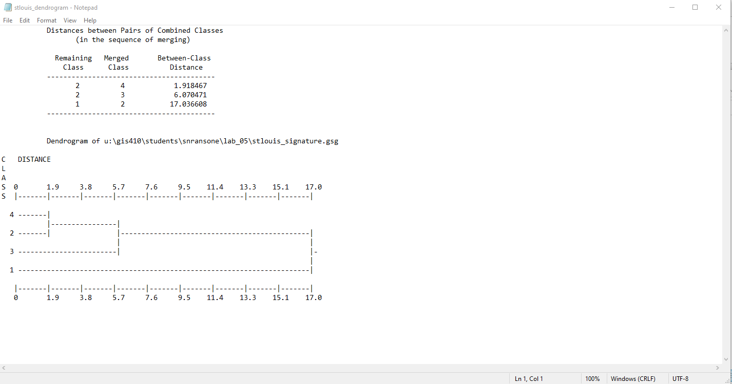

**Classes 1 and 2 will be the easiest to separate, with a between-class distance of 17.036608. Classes 2 and 4 will be the hardest to separate. This is surprising to me as class 2 is developed land and class 4 is cropland and pastures. The closeness of their spectral signatures likely arises from the fact that they are both medium hued colors and that croplands and pastures are multicolored, with many being semi-similar to the developed land.**

Q2: Given these spectral response curves, which two classes will be easiest to classify? Which two classes will be the hardest to classify? Explain your answer. (6 points)

**Water and Developed will be the easiest to identify. Around the 900 nanometer range they have the most variation from other points. Forest and Crop/Pasture will be the two hardest to identify for the same reasoning, they have very similar spectral profiles in that 900 nanometer range.**

Q3: Use these spectral response curves to explain why is it useful to have multiple spectral bands when trying to separate different land use and land cover classes. (8 points)

**It would be best to have multiple spectral bands when trying to differentiate land cover types to maximize the accuracy of the classifications. If you only had bands at low or high frequencies, it is likely that you would classify many pixels incorrectly because of how they are clustered. If you use multiple bands, you can select ranges at which certain land covers are distinct and can reduce the incorrect classifications.**

Q4: Which two bands best differentiate between the four LULC classes? (4 points)

**The best bands to differentiate between the LULC classes would be the red and near IR bands.**

Q5: Describe the classification clean-up process and the effect it has on the supervised classification? (4 points)

Q6: What classes have overlap that could cause confusion? How would adding more clusters to the unsupervised classification eliminate some of this overlap? (8 points)

**Forest and cop/Pasture have some overlap, some of the pastures are similar colors of green as the forests. Also weirdly developed had some overlap with both pastures and water. Water makes a bit of sense as it is a dingy, dirty dark color that is similar to parts of the developed city area. A couple of the pastures are drabber colors so they were originally assigned to develop before assigning more pasture colors to the correct class.**

Q7: Comparing the results of the unsupervised and supervised classifications, aside from actual land cover change, what are some other reasons why the results from the supervised and unsupervised classifications differ? (6 points)

**The primary reason behind differences in the supervised and unsupervised classification is selection bias, routed in user error. Unsupervised classification requires us to assign a pixel of a certain value to a land cover type, if the pixel value exists in a different land cover type it will be essentially manually overwritten into the value you selected. With supervised classification the count of specific values and the surrounding pixels play a role in the classification of each pixel.**

Q8: What is a mixed pixel? What effect does a mixed pixel have on classification accuracy? How are the spatial resolution of the original satellite image and the mixed pixels related? (6 points)

**A mixed pixel is a pixel that includes information that belongs to 2 separate classes. For instance a pixel near the bank of a river running through a city is likely to be identified incorrectly as it can’t split its value. Spatial resolution and mixed pixels are related because as spatial resolution increases the pixels will be more defined, taking up a smaller area on the ground and leading to a decrease in the count of mixed pixels in the imagery.**

Q9: In your opinion, which classification method produced the most accurate classification? Explain your answer. (6 points)

**Supervised is definitely more accurate in my images. This is likely because supervised classification takes into account all of the pixels that are contained within your polygons, giving you a larger variation in pixel values that the classification method will consider when assigning values to the pixel. Unsupervised classification is entirely dependent on the user to select and assign values to classifications, meaning that if two classifications have similar value but different classification it is likely that they will be classified incorrectly. This is evident in my imagery, as there is a large portion of the developed suburbs to the west of the city center that is classified as Crop/Pasture when it is very obviously developed.**

**IMAGES TO INCLUDE:**

**Supervised Classification**

Step 2 #11. Spectral signatures for your training sites.

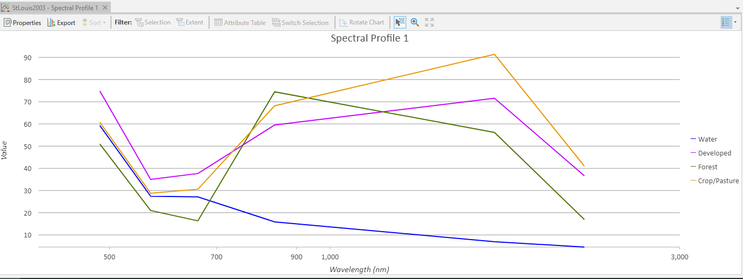

Step 3 #21. Supervised classification.

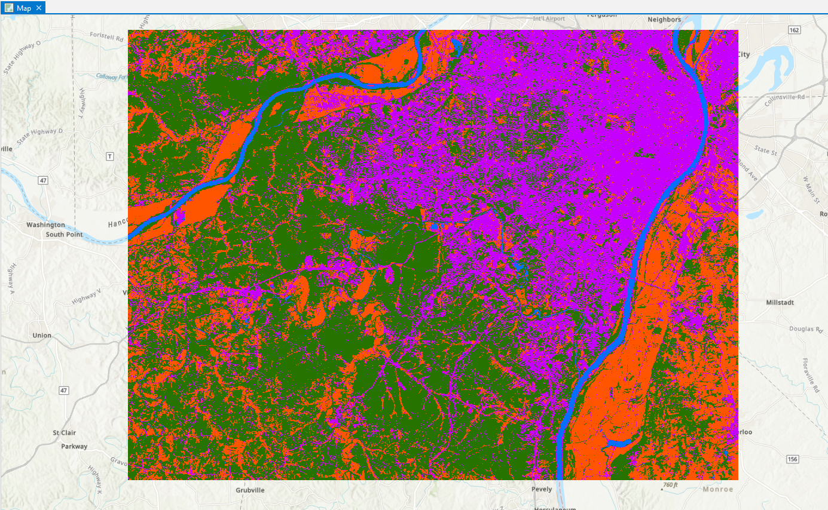

**Unsupervised Classification**

Step 3 #11. Unsupervised classification.

